# **Tree Monitoring Application**

As we know that trees are the true source which benefits us in many different ways such as they are used for cooking purposes, furniture, Paper generation and animal fodders etc.

Nowadays, people are cutting down trees just to satisfy their needs which is causing deforestation which in turn is causing many problems such as Air pollution, No rainfall, No homes for flying creatures etc. To overcome this, our government has declared an environment day to plant trees to an environment an eco -friendly.

As we see, most of the people plants trees on this days, but the problem is once they plant they may forget the maintain the growth of that plant such as how healthy the plant is, is it height is growing correctly, are they generating fruits etc. Due to lack of monitoring most of the plants do not grow and start diminishing due to lac of water and proper care.

### Proposed Solution:

Our goal is to locate any trees around your neighbourhood on geolocation. Through the web portal anyone can check the status of the tree nearby also they can check the health of the tree. One can register himself/herself on web browser while planting any plant from anywhere and can enrol the location as well for particular tree.

### Project Roadmap

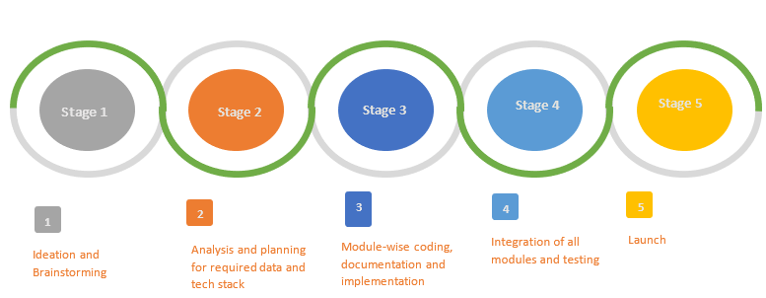

## **Technology Stack**

## **The Architecture/ Workflow**

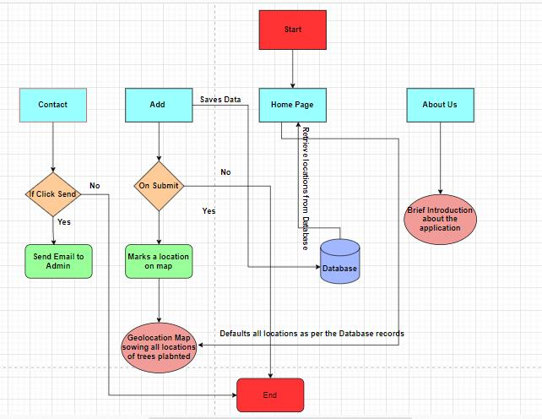

## **Screenshots**

### Add New Tree Information

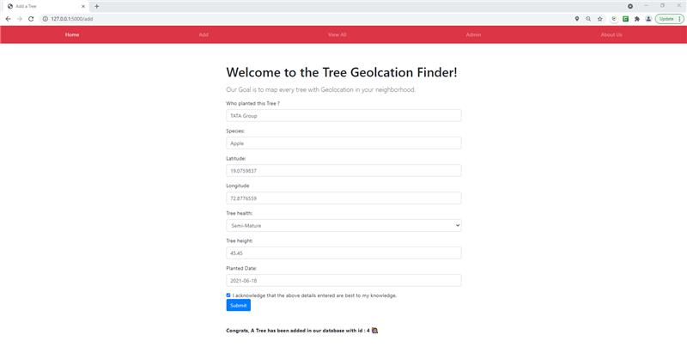

### Geo- location of a tree with its details along with QR Code

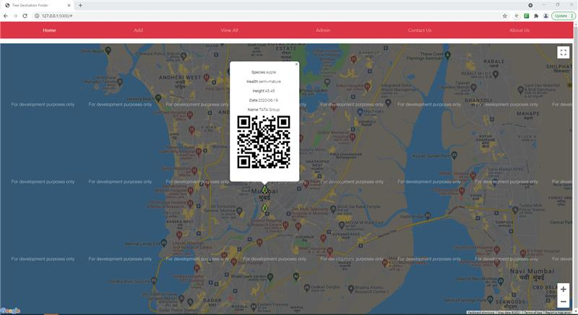

### About Us

### Contact Us

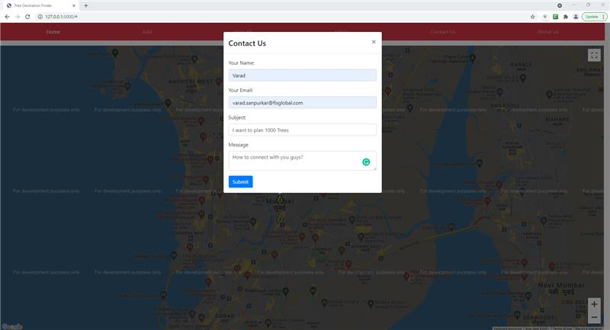

# **Ideation**

1. In future, we may have a tree count of any specific geolocation in the graphical format on monthly basis.
2. In order to get live tracking of plants, sensors can be placed at tree locations, with this we will be able to track health of the tree as expected.
3. There is scope to implement Image processing concepts with which we can track live health status of the plant by observing it’s colour, height and freshness of trees etc.
4. In future, we can integrate this database with an centralised Database which is used across by all NGO's, Based on analytics we can find the details such as which all species can be found under which location.

## Conclusion

This application will benefits us in tracking the number of tree planted on specific geolocation, Tree health etc. Using this information we can save many trees from diminishing due to lack of water and other factors.

## **About Authors**

1. **Aliya Parveen**

Role: Software Engineer

Experience: 3+ years

Technologies worked on: Html5, Css, Bootstrap4, Javascript, As400, SQL, Nodejs, MongoDB, DECISIONS (tool).

Company: Fidelity Information Services (FIS)

1. **Mayuri Gujar**

Role: Senior Software Engineer

Experience: 4+ years

Technologies worked on python, Oracle, JAVA, HTML, CSS, DECISIONS (tool).

Company: Fidelity Information Services (FIS)

1. **Varad Sanpurkar**

Role: Software Engineer I

Experience: 3 years

Technology: C#, ASP .NET, MVC, Python, SQL, JavaScript

Company: Fidelity Information Services (FIS)

1. **Vinayak Sharma**

Role: Software Engineer

Experience: 4 Years

Technologies worked on: Python, Machine Learning, SQL.

Company: Fidelity Information Services (FIS)

1. **Bhupal Patil**

Role: Development Manager

Experience: 15.5 Years

Technologies worked on: Microsoft Azure, ASP.NET MVC/WPF, C#,Visual Basic .NET, Azure IoT Hub, DevOps (Jenkins/TeamCity/Azure DevOps), SQL Server/Oracle

Company: Fidelity Information Services (FIS)

1. **Nupur Dande**

Role: Senior Developer

Experience: 11yrs

Technologies worked on: RPA and Automation, microsoft technologies, SQL